**Annual Complaints & Service Improvement Report 2024-25**

**Date: 1st May 2025**

|  |  |
| --- | --- |
| **Title** | **Annual Complaints & Service Improvement Report** |
| **Author** | Rachel Bradley |
| **Date Reviewed** | April 2025 |
| **Next Review** | April 2026 |
| **Purpose** | To update the Board on the changes made to the complaints handling self-assessment. To share annual performance, trends and the service improvements which have been identified for improvement. |

1. **Purpose & Vision**

Here at Hellens Residential, we are committed to delivering the highest level of customer service. Our vision is to create sustainable communities for people to live and work.

However, we know that we do not always get this right and therefore we encourage feedback from our customers to ensure that we can continually fine tune and improve the service we provide.

As a small Registered Provider of Social Housing we are not able to have a dedicated team for managing complaints. We do have a member of staff who has responsibility for Complaints and feeds directly in to the Managing Director. This provides the Directors with a clear visibility of all complaints that we are handling and the resulting outcomes.

1. **Context**

In April 2025 the Board was updated on Hellens Residential’s compliance against the revised Housing Ombudsman Complaint Handling Code. The Code came in to effect from the 1st April 2024.

Sections 8.1 and 8.2 of the code state that: Landlords must produce an annual complaints performance and service improvement report for scrutiny and challenge, which must include:

1. the annual self-assessment against this Code to ensure their complaint handling policy remains in line with its requirements.
2. a qualitative and quantitative analysis of the landlord’s complaint handling performance. This must also include a summary of the types of complaints the landlord has refused to accept;
3. any findings of non-compliance with this Code by the Ombudsman;
4. the service improvements made as a result of the learning from complaints;
5. any annual report about the landlord’s performance from the Ombudsman;
6. any other relevant reports or publications produced by the Ombudsman in relation to the work of the landlord.

The annual complaints performance and service improvement report must be reported to the landlord’s governing body (or equivalent) and published on the section of its website relating to complaints. The governing body’s response to the report must be published alongside this.

1. **Self-assessment against the Complaints Handling Code**

The self-assessment, which is published on our website has been updated. We are happy to report that we are fully compliant with the Housing Ombudsman’s Complaint Handling Code and there are no areas of non-compliance.

The self-assessment will be reviewed if any of the following circumstances occur:

* There be a significant restructure, merger and/or change in procedures
* Following an investigation from the Housing Ombudsman
* Annually

1. **Qualitative and Quantitative analysis of the Complaints Handling Process**

During 2024/2025 we received   
**6**  
Stage 1   
Complaints

During 2024/2025 we received   
**1**   
Stage 2   
Complaints

|  |  |
| --- | --- |
|  | **2024-2025** |
| **Number of formal Complaints received during the year** | 6 |
| **Percentage of Stage 1 complaints responded to within target** | 100% |
| **Percentage of complaints resolved at Stage 1** | 83.33% |
| **Number of Complaints progressing to Stage 2** | 1 |
| **Percentage of Stage 2 complaints responded to within target** | 100% |
| **Number of complaints resulting in compensation being paid** | 3 |

Due to being a Registered Provider with under 300 units, we do not receive an excessive number of complaints and therefore it can be harder to identify trends or themes in the complaints received.

There was 1 complaint that we failed to respond to within target. An extension of all of these was agreed with the customer. The reasons for this included:

* Seeking updates from the Developer of a new build property before we were able to assess the issues in full.

Of the complaints received the below pie chart illustrates the categories which they fall in to:

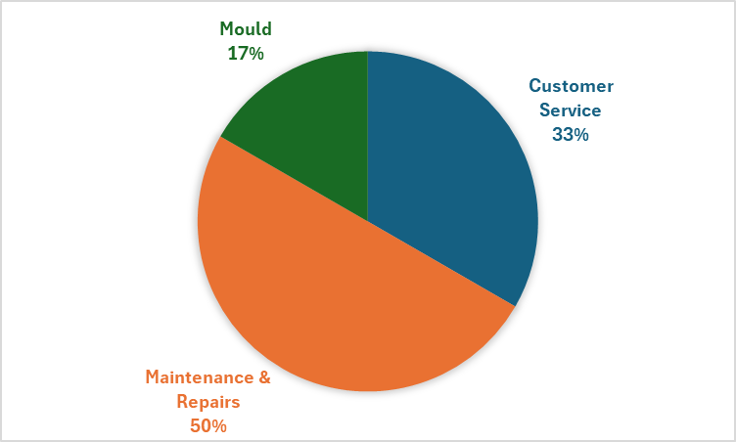

The majority of complaints were in relation to maintenance and repairs not getting resolved within timescales expected by the tenants. Whilst the numbers are relatively low, we felt this required greater scrutiny given it is an area we can directly improve with the service we provide.

Following maintenance visits, we have started sending out a survey to customers on an ad-hoc basis to ensure we monitor the service we are providing and can proactively correct should it not be up to our desired standard.

We collect customer satisfaction via a perception survey as part of the annual Tenant Satisfaction Measures (TSMs), which are reported to the Regulator of Social Housing (RSH). There is a direct correlation between how satisfied customers are with the repair works and the overall approach to complaints. This needs to be monitored in more detail going forward to identify specific trends.

1. **Summary of types of complaints Hellens Residential refused to accept**

During 2024-25 there were no complaints that we did not accept.

1. **Any findings of non-compliance with the Complaints Handling Code by the Housing Ombudsman**

We have had no findings of non-compliance with the Complaints Handling by the Housing Ombudsman.

1. **Service improvements made as a result of the learning from complaints**

|  |  |
| --- | --- |
| You Said | We Did |
| Repairs & Maintenance works were getting carried out too slow | Implemented a new Housing / Tenancy Management system to help with coordinating and monitoring repairs. |
| I have concerns over damp & mould in my property | Appointed a dedicated employee to ensuring all properties are checked annually and any queries dealt with quickly and efficiently. Sent out regular emails to all tenants to check if mould was found in their property in between annual home visits. |
| I want to be able to communicate with you more online than over the phone | Implemented a new Housing Management system which lets you send messages, report repairs, check your rent balance etc. |
| You didn’t appreciate being chased for rent via email when it is only a small amount | Monitor customer service positive and negative feedback on a weekly basis in our internal Housing Management meeting with the Managing Director. |
| Our response times for complaints could be quicker | Implemented a new digital complaints management system to improve record keeping, monitoring of targets and identification of themes. |