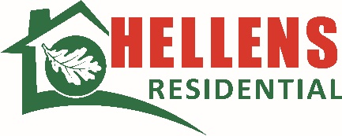
Board Response to the Annual Complaints Report 2024-25
Date: 1st May 2025
Title | Board Response to the Annual Complaints Report
Approved By | Hellens Residential Board
Date Reviewed | May 2025
Next Review | April 2026
Purpose | To update the Board on the changes made to the complaints handling self-assessment. To share annual performance, trends and the service improvements which have been identified for improvement.

- Kate Hellens, Managing Director (on behalf of the Board)
The Board has reviewed and approved the Annual Complaints Report, ensuring a proactive approach to a
ddressing customers dissatisfaction and leveraging complaints to drive services improvements going forward.
Ensuring we are listening to our residents and that we are working together to provide the services and support is paramount to us.
This report demonstrates our commitment to continuous improvement due to the strong level of compliance with the Complaint Handling Code. As a small Registered Provider of Social Housing it is challenging to notice trends in the complaints however as a team we are closely monitoring this to ascertain any underlying or repeating issues.
We note there are areas for improvement and further training will be delivered to our employees to ensure we provide the highest level of customer service to our residents.
As ever we are continually committed to ensuring customer service is at for forefront of everything we do.
With this being the second year of submissions, there has been greater scrutiny and regard to complaints at all levels of the business. It has been encouraging to see the proactive approach taken to Complaints handling.

